
10111026 – KARISMA AINUN NISSA
SI 2B

JOB SHEET
PEMROGRAMAN BERORIENTASI OBJEK
PERTEMUAN 11
Dosen Pengampu
Sari Azhariyah, M.Pd.T.
Usep Abdul Rosid, S.T., M.Kom

POLITEKNIK NEGERI SUBANG
Jurusan : TIK | Waktu : 240 Menit
Program Studi : Sistem Informasi | Topik : Rancang Bangun Sistem Informasi Berbasis Web OOP 2 CRUD (Create, Read, Update, Delete) Fundamental
Mata Kuliah : PBO | Judul : Rancang Bangun Sistem Informasi Berbasis Web OOP 2 CRUD (Create, Read, Update, Delete) Fundamental
Tanggal : 5 November 2025 | Pertemuan ke : 11

Tujuan : Mahasiswa mampu memahami dan menjelaskan konsep dasar dan mengimplementasi serta berlatih penggunaan elemen pada HTML.

Alat dan Bahan : XAMPP, Web Browser, Text Editor

Link Github : https://github.com/karisss26/karis_2B_PBO.git
Langkah Kerja :
- Siapkan dan jalankan xampp, web browser, dan text editor
- Buat folder praktikum pemrograman web pada folder htdocs
- Lakukan penulisan sintak program pada text editor
- Simpan file hasil penulisan sintak tersebut kedalam folder praktikum
- Jalankan web browser
- Jalankan web pada mode local dengan mengetikan localhost/folder praktikum/file sintak pada web browser
- Output program akan tampil pada web browser

No | Praktik | Output Program | Sintak Kode Program | Keterangan
1. | Memperbarui database | 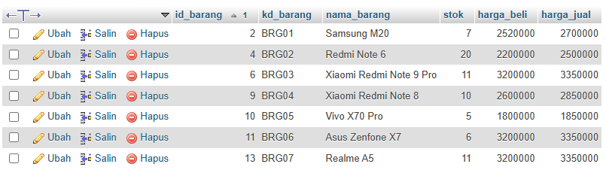 | ALTER TABLE tb_barang  MODIFY id_barang INT NOT NULL;  ALTER TABLE tb_barang  ADD COLUMN kd_barang VARCHAR(100) AFTER id_barang;  INSERT INTO tb_barang (id_barang, kd_barang, nama_barang, stok, harga_beli, harga_jual)  VALUES  (2, 'BRG01', 'Samsung M20', 7, 2520000, 2700000),  (4, 'BRG02', 'Redmi Note 6', 20, 2200000, 2500000),  (6, 'BRG03', 'Xiaomi Redmi Note 9 Pro', 11, 3200000, 3350000),  (9, 'BRG04', 'Xiaomi Redmi Note 8', 10, 2600000, 2850000),  (10, 'BRG05', 'Vivo X70 Pro', 5, 1800000, 1850000),  (11, 'BRG06', 'Asus Zenfone X7', 6, 3200000, 3350000),  (13, 'BRG07', 'Realme A5', 11, 3200000, 3350000); | Memperbarui table pada database belajar_oop
2. | Merancang struktur file | 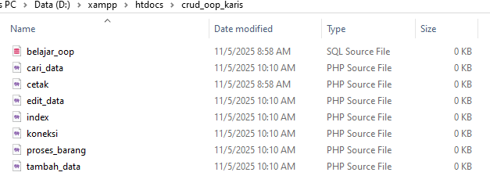 |  | Merancang struktur file dan file php pendukung
3. | Koneksi.php | 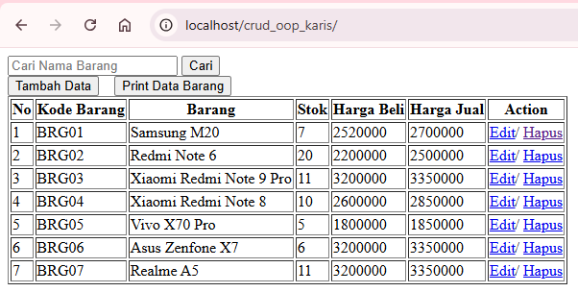 | <?php  class database {  var $host = "localhost";  var $username = "root";  var $password = "";  var $database = "belajar_oop";  var $koneksi = "";  function __construct(){  $this->koneksi = mysqli_connect($this->host, $this->username, $this->password, $this->database);  if (mysqli_connect_error()){  echo "Koneksi database gagal : " . mysqli_connect_error();  }  }  function tampil_data(){  $data = mysqli_query($this->koneksi, "select * from tb_barang");  while ($row = mysqli_fetch_array($data)){  $hasil[] = $row;  }  return $hasil;  }  function tambah_data($id_barang, $nama_barang, $stok, $harga_beli, $harga_jual){  mysqli_query($this->koneksi, "insert into tb_barang values ('', '$id_barang', '$nama_barang', '$stok', '$harga_beli', '$harga_jual')");  }  function tampil_edit_data($id_barang){  $data = mysqli_query($this->koneksi, "select * from tb_barang where id_barang='$id_barang'");  while ($d = mysqli_fetch_array($data)){  $hasil[] = $d;  }  return $hasil;  }  function edit_data($id_barang, $nama_barang, $stok, $harga_beli, $harga_jual){  mysqli_query($this->koneksi, "update tb_barang set nama_barang='$nama_barang', stok='$stok', harga_beli='$harga_beli', harga_jual='$harga_jual' where id_barang='$id_barang'");  }  function delete_data($id_barang){  mysqli_query($this->koneksi, "delete from tb_barang where id_barang='$id_barang'");  }  function kode_barang(){  $data = mysqli_query($this->koneksi, "SELECT MAX(id_barang) as kd_barang FROM tb_barang");  while ($row = mysqli_fetch_array($data)){  $hasil[] = $row;  }  return $hasil;  }  }  ?> | Koding file koneksi.php sebagai model
4. | Proses_barang.php | 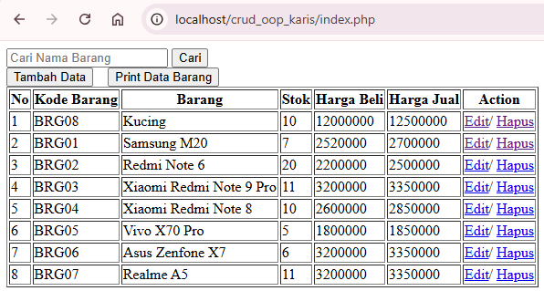  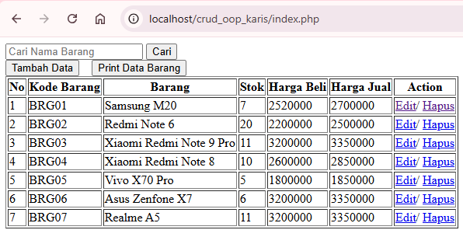 | <?php  include ('koneksi.php');  $koneksi = new database();  $action = $_GET['action'];  if ($action == "add"){  $koneksi->tambah_data($_POST['kd_barang'], $_POST['nama_barang'], $_POST['stok'], $_POST['harga_beli'], $_POST['harga_jual']);  header("location:index.php");  } else if ($action == "edit"){  $id_barang = $_GET['id_barang'];  $koneksi->edit_data($id_barang, $_POST['nama_barang'], $_POST['stok'], $_POST['harga_beli'], $_POST['harga_jual']);  header("location:index.php");  } else if ($action == "delete"){  $id_barang = $_GET['id_barang'];  $koneksi->delete_data($id_barang);  header("location:index.php");  }  ?> | Koding file proses_barang.php sebagai controller
5. | Index.php | 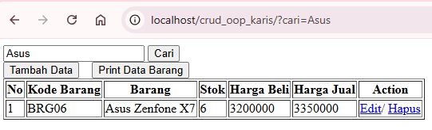 | <?php  include ('koneksi.php');  $koneksi = new database();  $data_barang = $koneksi->tampil_data();  $koneksi = mysqli_connect("localhost","root","","belajar_oop");  ?>  <!DOCTYPE html>  <html>  <head>  <title>cetak</title>  <style type="text/css">  form {background:border}  margin: 0px 300px;  color:white;  </style>  </head>  <body>  <form id="background_border" method="get">  <input type="text" name="cari" placeholder="Cari Nama Barang">  <input type="submit" value="Cari">  </form>  <a href="tambah_data.php"><button>Tambah Data</button></a>&nbsp;&nbsp;&nbsp;  <a href="cetak.php" target="_BLANK"><button>Print Data Barang</button></a>  <table border="1">  <tr>  <th>No</th>  <th>Kode Barang</th>  <th>Barang</th>  <th>Stok</th>  <th>Harga Beli</th>  <th>Harga Jual</th>  <th>Action</th>  </tr>  <?php  $no = 1;  foreach($data_barang as $row){  ?>  <tr>  <td><?php echo $no++; ?></td>  <td><?php echo $row['kd_barang']; ?></td>  <td><?php echo $row['nama_barang']; ?></td>  <td><?php echo $row['stok']; ?></td>  <td><?php echo $row['harga_beli']; ?></td>  <td><?php echo $row['harga_jual']; ?></td>  <td>  <a href="edit_data.php?id_barang=<?php echo $row['id_barang']; ?>&action=edit">Edit</a>/  <a href="proses_barang.php?id_barang=<?php echo $row['id_barang']; ?>&action=delete">Hapus</a>  </td>  </tr>  <?php  }  ?>  </table>  </body>  </html> | Koding file ondex.php sebagai view dan delete data
6. | Tambah_data.php | 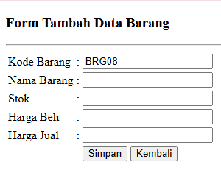 | <?php  include ('koneksi.php');  $db = new database();  ?>  <!DOCTYPE html>  <html>  <head>  <title></title>  </head>  <body>  <h3>Form Tambah Data Barang</h3>  <hr>  <?php  $kode_barang = $db->kode_barang();  foreach($kode_barang as $row){  $kode_max = $row['kd_barang'];  }  $pecahdata = explode('0', $kode_max);  $kode_barangbaru = $pecahdata[0]."0".($pecahdata[1]+1);  ?>  <form method="post" action="proses_barang.php?action=add">  <table>  <tr>  <td>Kode Barang</td>  <td>:</td>  <td><input type="text" name="kd_barang" value="<?php echo $kode_barangbaru;?>" readonly></td>  </tr>  <tr>  <td>Nama Barang</td>  <td>:</td>  <td><input type="text" name="nama_barang"></td>  </tr>  <tr>  <td>Stok</td>  <td>:</td>  <td><input type="text" name="stok"></td>  </tr>  <tr>  <td>Harga Beli</td>  <td>:</td>  <td><input type="text" name="harga_beli"></td>  </tr>  <tr>  <td>Harga Jual</td>  <td>:</td>  <td><input type="text" name="harga_jual"></td>  </tr>  <tr>  <td></td>  <td></td>  <td>  <input type="submit" name="tombol" value="Simpan">  <a href="index.php">  <input type="button" name="tombol" value="Kembali"></a>  </td>  </tr>  </table>  </form>  </body>  </html> | Koding file tambah_data.php dengan kode otomatis
7. | Edit_data.php | 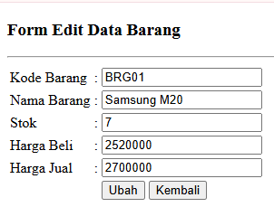 | <?php  include ('koneksi.php');  $db = new database();  $id_barang = $_GET['id_barang'];  $data_edit_barang = $db->tampil_edit_data($id_barang);  ?>  <!DOCTYPE html>  <html>  <head>  <title></title>  </head>  <body>  <h3>Form Edit Data Barang</h3>  <hr>  <?php  foreach($data_edit_barang as $d){  ?>  <form method="post" action="proses_barang.php?action=edit&id_barang=<?php echo $d['id_barang']; ?>">  <table>  <tr>  <td>Kode Barang</td>  <td>:</td>  <td>  <input type="hidden" name="id_barang" value="<?php echo $d['id_barang']; ?>">  <input type="text" name="kd_barang" value="<?php echo $d['kd_barang']; ?>" readonly>  </td>  </tr>  <tr>  <td>Nama Barang</td>  <td>:</td>  <td><input type="text" name="nama_barang" value="<?php echo $d['nama_barang']; ?>"></td>  </tr>  <tr>  <td>Stok</td>  <td>:</td>  <td><input type="text" name="stok" value="<?php echo $d['stok']; ?>"></td>  </tr>  <tr>  <td>Harga Beli</td>  <td>:</td>  <td><input type="text" name="harga_beli" value="<?php echo $d['harga_beli']; ?>"></td>  </tr>  <tr>  <td>Harga Jual</td>  <td>:</td>  <td><input type="text" name="harga_jual" value="<?php echo $d['harga_jual']; ?>"></td>  </tr>  <tr>  <td></td>  <td></td>  <td>  <input type="submit" name="tombol" value="Ubah">  <a href="tampil_data.php">  <input type="submit" name="tombol" value="Kembali"></a>  </td>  </tr>  </table>  </form>  <?php  }  ?>  </body>  </html> | Koding file edit_data.php sebagai view
8. | cetak.php | 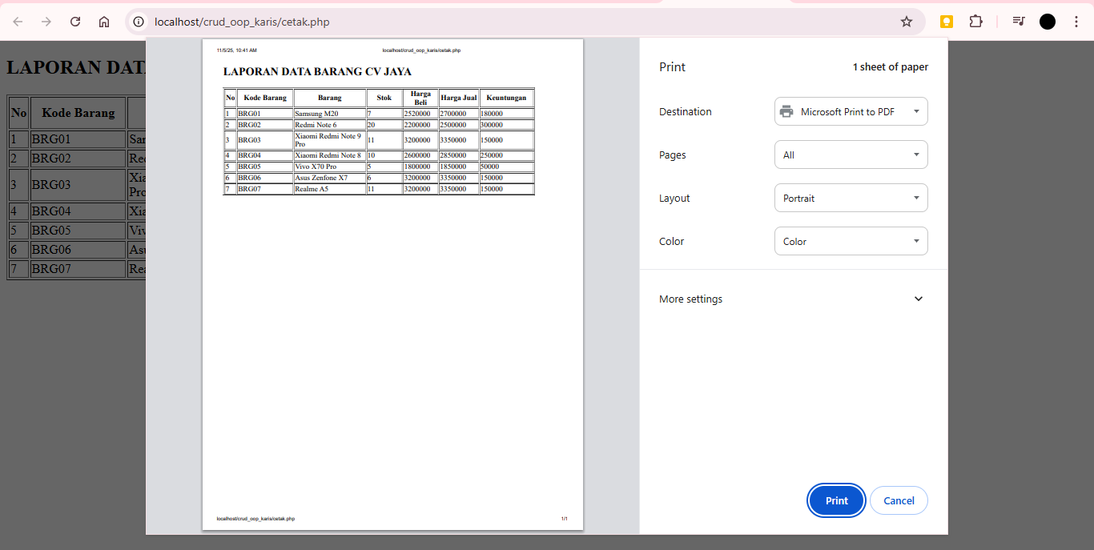 | <?php  include ('koneksi.php');  $db = new database();  ?>  <!DOCTYPE html>  <html>  <head>  <title></title>  <style type="text/css">  form {background:border}  margin: 0px 230px;  color:white;  </style>  </head>  <body>  <h2>LAPORAN DATA BARANG CV JAYA</h2>  <table width="667" border="1">  <tr>  <th width="21">No</th>  <th width="122">Kode Barang</th>  <th width="158">Barang</th>  <th width="77">Stok</th>  <th width="72">Harga Beli</th>  <th width="83">Harga Jual</th>  <th width="114">Keuntungan</th>  </tr>  <?php  $data_barang = $db->tampil_data();  $no = 1;  foreach($data_barang as $row){  ?>  <tr>  <td><?php echo $no++; ?></td>  <td><?php echo $row['kd_barang']; ?></td>  <td><?php echo $row['nama_barang']; ?></td>  <td><?php echo $row['stok']; ?></td>  <td><?php echo $row['harga_beli']; ?></td>  <td><?php echo $row['harga_jual']; ?></td>  <td><?php echo $row['harga_jual']-$row['harga_beli']; ?></td>  </tr>  <?php  }  ?>  </table>  <script>  window.print();  </script>  </body>  </html> | Koding file cetak.php untuk pencetakan laporan
9. | Menambah tb_customer | 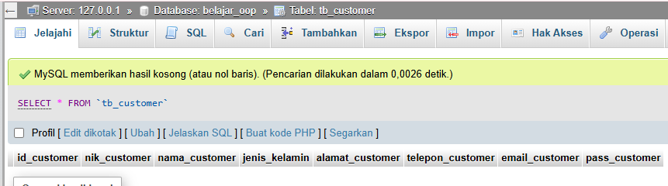 | CREATE TABLE `tb_customer` (  `id_customer` VARCHAR(100) NOT NULL, -- PRIMARY KEY: akan menyimpan CS001, CS002, dst.  `nik_customer` VARCHAR(100) NOT NULL,  `nama_customer` VARCHAR(100) NOT NULL,  `jenis_kelamin` VARCHAR(100) NOT NULL,  `alamat_customer` TEXT NOT NULL,  `telepon_customer` VARCHAR(100) NOT NULL,  `email_customer` VARCHAR(100) NOT NULL,  `pass_customer` VARCHAR(100) NOT NULL,  PRIMARY KEY (`id_customer`)  ) ENGINE=InnoDB DEFAULT CHARSET=utf8mb4 COLLATE=utf8mb4_general_ci; | Menambahkan table tb_customer di database untuk dashboard customer
10. | Menambahkan tb_supplier | 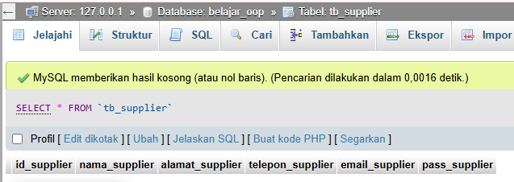 | CREATE TABLE `tb_supplier` (  `id_supplier` VARCHAR(100) NOT NULL,  `nama_supplier` VARCHAR(100) NOT NULL, -- Mengubah TEXT menjadi VARCHAR(100)  `alamat_supplier` TEXT NOT NULL,  `telepon_supplier` VARCHAR(100) NOT NULL,  `email_supplier` VARCHAR(100) NOT NULL,  `pass_supplier` VARCHAR(100) NOT NULL,  PRIMARY KEY (`id_supplier`)  ) ENGINE=InnoDB DEFAULT CHARSET=utf8mb4 COLLATE=utf8mb4_general_ci; | Menambah table tb_supplier pada database untuk dashboard supplier
 | Studi Kasus (menambah fitur cetak satuan) | 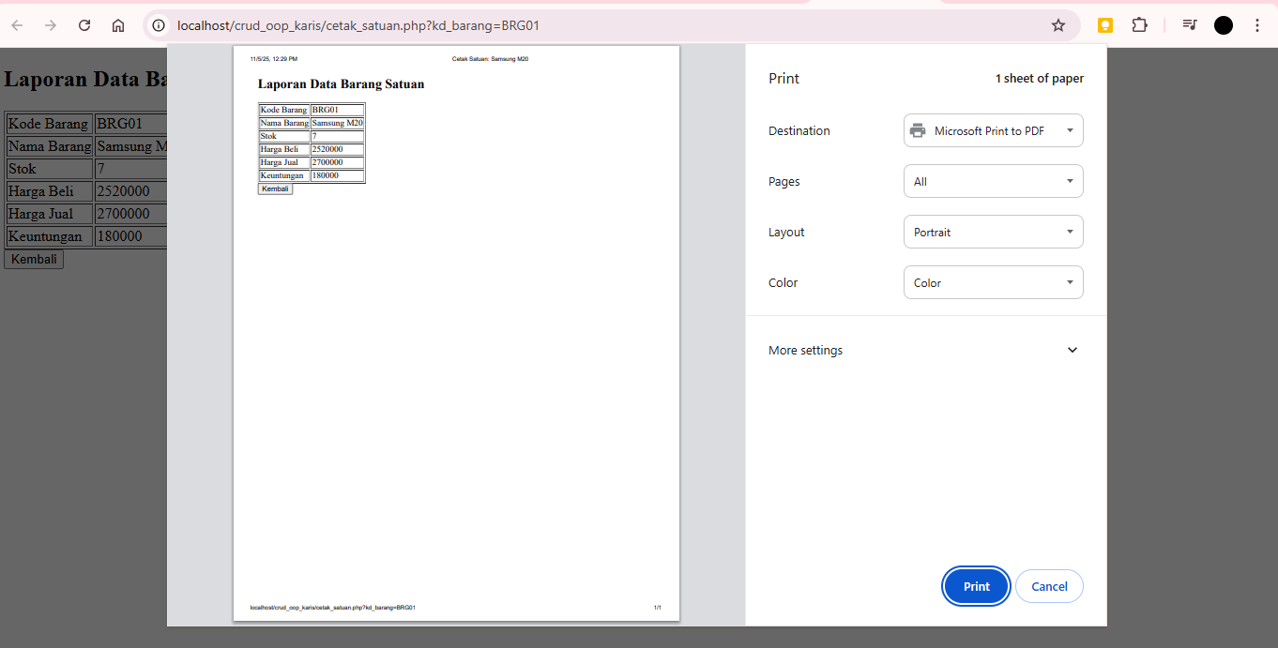 | <?php  session_start();  include ('koneksi.php');  $db = new database();  if($_SESSION['status'] != "login"){  header("location:login.php");  exit();  }  $kd_barang = isset($_GET['kd_barang']) ? $_GET['kd_barang'] : die("Kode barang tidak ditemukan.");  $data = $db->tampil_data_per_kode($kd_barang);  if (!$data) {  die("Data barang dengan kode **$kd_barang** tidak ditemukan!");  }  ?>  <!DOCTYPE html>  <html>  <head>  <title>Cetak Satuan: <?php echo $data['nama_barang']; ?></title>  </head>  <body>  <h2>Laporan Data Barang Satuan</h2>  <table border="1">  <tr><td>Kode Barang</td><td><?php echo $data['kd_barang']; ?></td></tr>  <tr><td>Nama Barang</td><td><?php echo $data['nama_barang']; ?></td></tr>  <tr><td>Stok</td><td><?php echo $data['stok']; ?></td></tr>  <tr><td>Harga Beli</td><td><?php echo $data['harga_beli']; ?></td></tr>  <tr><td>Harga Jual</td><td><?php echo $data['harga_jual']; ?></td></tr>  <tr><td>Keuntungan</td><td><?php echo $data['harga_jual'] - $data['harga_beli']; ?></td></tr>  </table>  <script>  window.print();  </script>  <a href="index.php">  <input type="submit" name="tombol" value="Kembali"></a>  </body>  </html> | Menambah fitur cetak data per barang pada data barang
 | Studi Kasus (Menambah menu data customer dan supplier) | 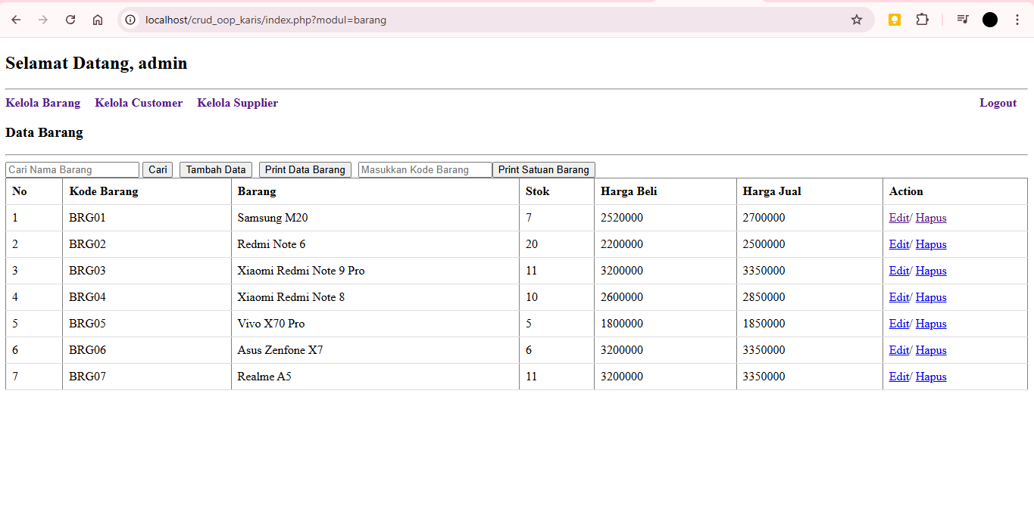  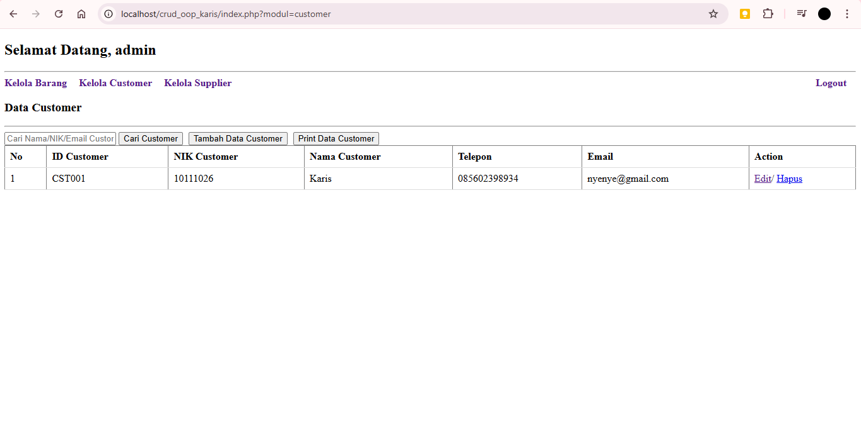  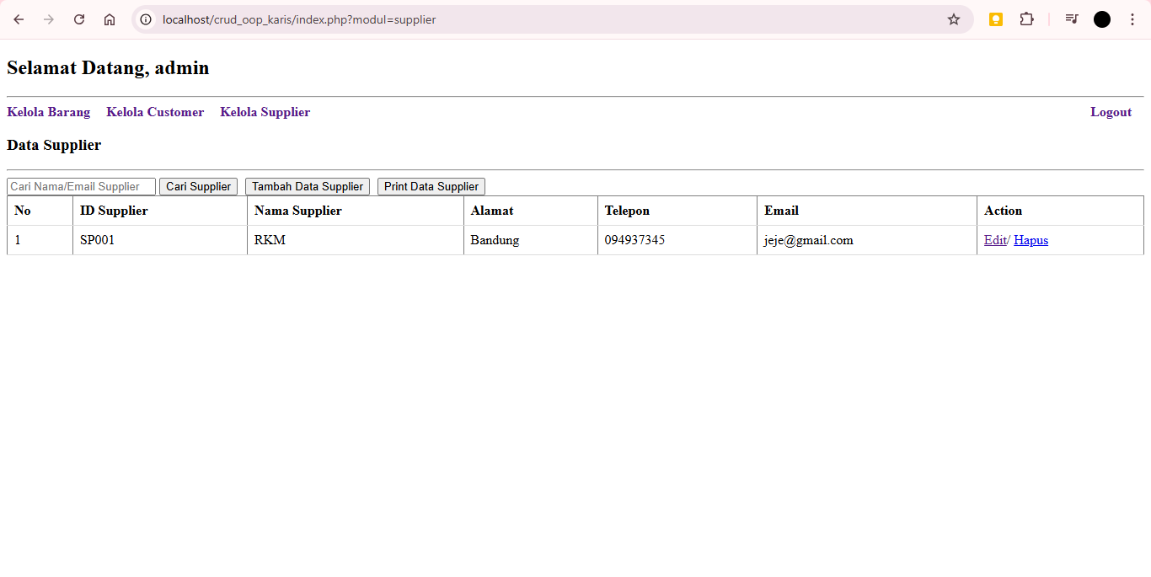 | <?php  // File: index.php (Dashboard, Barang, Customer, Supplier View)  session_start();  if($_SESSION['status'] != "login"){  header("location:login.php?pesan=belum_login");  exit();  }  include ('koneksi.php');  $koneksi = new database();  $tipe_user = $_SESSION['tipe_user'];  $modul = isset($_GET['modul']) ? $_GET['modul'] : 'barang';  $data_tampil = [];  $nama_modul = "";  $kata_kunci = "";  // Logika Pengambilan Data  if ($modul == 'barang') {  $nama_modul = "Barang";  $kata_kunci = isset($_GET['cari']) ? $_GET['cari'] : '';  // Memanggil fungsi tampil_data yang sudah mendukung pencarian  $data_tampil = $koneksi->tampil_data($kata_kunci);  } elseif ($modul == 'customer' && ($tipe_user == 'Administrator' || $tipe_user == 'Staf')) {  $nama_modul = "Customer";  $kata_kunci = isset($_GET['cari']) ? $_GET['cari'] : '';  // Memanggil fungsi tampil_data_customer yang sudah mendukung pencarian  $data_tampil = $koneksi->tampil_data_customer($kata_kunci);  } elseif ($modul == 'supplier' && $tipe_user == 'Administrator') {  $nama_modul = "Supplier";  $kata_kunci = isset($_GET['cari']) ? $_GET['cari'] : '';  // Memanggil fungsi tampil_data_supplier yang sudah mendukung pencarian  $data_tampil = $koneksi->tampil_data_supplier($kata_kunci);  } else {  // Fallback  $modul = 'barang'; $nama_modul = "Barang"; $data_tampil = $koneksi->tampil_data();  }  ?>  <!DOCTYPE html>  <html>  <head>  <title>Kelola Data <?php echo $nama_modul; ?></title>  <style type="text/css">  table { width: 100%; border-collapse: collapse; }  th, td { padding: 8px; text-align: left; border-bottom: 1px solid #ddd; }  #menu_akses a { margin-right: 15px; text-decoration: none; font-weight: bold; }  .inline-button { display: inline-block; margin-right: 5px; }  </style>  </head>  <body>  <h2>Selamat Datang, <?php echo $_SESSION['username']; ?></h2>  <hr>  <div id="menu_akses">  <a href="?modul=barang">Kelola Barang</a>  <?php if($tipe_user == 'Administrator' || $tipe_user == 'Staf'): ?>  <a href="?modul=customer">Kelola Customer</a>  <?php endif; ?>  <?php if($tipe_user == 'Administrator'): ?>  <a href="?modul=supplier">Kelola Supplier</a>  <?php endif; ?>  <a href="logout.php" style="float: right;">Logout</a>  </div>  <h3>Data <?php echo $nama_modul; ?></h3>  <hr>  <?php if ($modul == 'barang'): ?>  <form method="get" style="display:inline;" class="inline-button">  <input type="hidden" name="modul" value="barang">  <input type="text" name="cari" placeholder="Cari Nama Barang" value="<?php echo htmlspecialchars($kata_kunci); ?>">  <input type="submit" value="Cari">  </form>  <a href="tambah_data.php" class="inline-button"><button>Tambah Data</button></a>  <a href="cetak.php" target="_BLANK" class="inline-button"><button>Print Data Barang</button></a>  <form method="get" action="cetak_satuan.php" target="_BLANK" style="display:inline;" class="inline-button">  <input type="text" name="kd_barang" placeholder="Masukkan Kode Barang"><input type="submit" value="Print Satuan Barang">  </form>  <table border="1">  <tr><th>No</th><th>Kode Barang</th><th>Barang</th><th>Stok</th><th>Harga Beli</th><th>Harga Jual</th><th>Action</th></tr>  <?php $no = 1; if (!empty($data_tampil)) { foreach($data_tampil as $row){ ?>  <tr><td><?php echo $no++; ?></td><td><?php echo $row['kd_barang']; ?></td><td><?php echo $row['nama_barang']; ?></td>  <td><?php echo $row['stok']; ?></td><td><?php echo $row['harga_beli']; ?></td><td><?php echo $row['harga_jual']; ?></td>  <td><a href="edit_data.php?id_barang=<?php echo $row['id_barang']; ?>&action=edit">Edit</a>/  <a href="proses_barang.php?id_barang=<?php echo $row['id_barang']; ?>&action=delete" onclick="return confirm('Yakin hapus?')">Hapus</a></td></tr>  <?php } } else { echo "<tr><td colspan='7' style='text-align:center;'>Hasil pencarian tidak ditemukan.</td></tr>"; } ?>  </table>  <?php elseif ($modul == 'customer'): ?>  <form method="get" style="display:inline;" class="inline-button">  <input type="hidden" name="modul" value="customer">  <input type="text" name="cari" placeholder="Cari Nama/NIK/Email Customer" value="<?php echo htmlspecialchars($kata_kunci); ?>">  <input type="submit" value="Cari Customer">  </form>  <a href="customer/tambah.php" class="inline-button"><button>Tambah Data Customer</button></a>  <a href="customer/cetak_customer.php" target="_BLANK" class="inline-button"><button>Print Data Customer</button></a>  <table border="1">  <tr><th>No</th><th>ID Customer</th><th>NIK Customer</th><th>Nama Customer</th><th>Telepon</th><th>Email</th><th>Action</th></tr>  <?php $no = 1; if (!empty($data_tampil)) { foreach($data_tampil as $row){ ?>  <tr><td><?php echo $no++; ?></td><td><?php echo $row['id_customer']; ?></td><td><?php echo $row['nik_customer']; ?></td>  <td><?php echo $row['nama_customer']; ?></td><td><?php echo $row['telepon_customer']; ?></td><td><?php echo $row['email_customer']; ?></td>  <td><a href="customer/edit.php?id_customer=<?php echo $row['id_customer']; ?>&action=edit">Edit</a>/  <a href="customer/proses.php?id_customer=<?php echo $row['id_customer']; ?>&action=delete" onclick="return confirm('Yakin hapus?')">Hapus</a></td></tr>  <?php } } else { echo "<tr><td colspan='7' style='text-align:center;'>Data customer belum tersedia atau tidak ditemukan.</td></tr>"; } ?>  </table>  <?php elseif ($modul == 'supplier'): ?>  <form method="get" style="display:inline;" class="inline-button">  <input type="hidden" name="modul" value="supplier">  <input type="text" name="cari" placeholder="Cari Nama/Email Supplier" value="<?php echo htmlspecialchars($kata_kunci); ?>">  <input type="submit" value="Cari Supplier">  </form>  <a href="supplier/tambah.php" class="inline-button"><button>Tambah Data Supplier</button></a>  <a href="supplier/cetak_supplier.php" target="_BLANK" class="inline-button"><button>Print Data Supplier</button></a>  <table border="1">  <tr><th>No</th><th>ID Supplier</th><th>Nama Supplier</th><th>Alamat</th><th>Telepon</th><th>Email</th><th>Action</th></tr>  <?php $no = 1; if (!empty($data_tampil)) { foreach($data_tampil as $row){ ?>  <tr><td><?php echo $no++; ?></td><td><?php echo $row['id_supplier']; ?></td><td><?php echo $row['nama_supplier']; ?></td>  <td><?php echo $row['alamat_supplier']; ?></td><td><?php echo $row['telepon_supplier']; ?></td><td><?php echo $row['email_supplier']; ?></td>  <td><a href="supplier/edit.php?id_supplier=<?php echo $row['id_supplier']; ?>&action=edit">Edit</a>/  <a href="supplier/proses.php?id_supplier=<?php echo $row['id_supplier']; ?>&action=delete" onclick="return confirm('Yakin hapus?')">Hapus</a></td></tr>  <?php } } else { echo "<tr><td colspan='7' style='text-align:center;'>Data supplier belum tersedia atau tidak ditemukan.</td></tr>"; } ?>  </table>  <?php else: ?>  <p>Modul tidak ditemukan atau akses ditolak.</p>  <?php endif; ?>  </body>  </html> | Menambah menu data customer dan supplier lengkap dengan crud dan print data

Analisis dan Penjelasan Kode Program dalam Soal Tes Praktikum :

Studi kasus ini adalah pengembangan sistem manajemen data inventaris dasar yang dibangun menggunakan PHP dan paradigma Object-Oriented Programming (OOP), di mana semua interaksi dengan database dikelola melalui sebuah Class database di file koneksi.php. Proyek ini berhasil diubah dari sistem pengelolaan barang tunggal menjadi sistem modular terintegrasi yang mampu mengelola data Barang, Customer, dan Supplier. Fitur utama yang ditambahkan mencakup sistem Login (menggunakan tabel user dengan hak akses Administrator dan Petugas), integrasi semua modul ke dalam satu halaman utama (index.php) melalui parameter URL (?modul=...), serta fungsionalitas CRUD lengkap, termasuk penomoran ID otomatis (CS001, SP001) dan fitur pencarian serta pencetakan laporan.
Organisasi file proyek ditingkatkan secara signifikan dengan membuat folder khusus (/customer/ dan /supplier/), memisahkan form (tambah.php, edit.php) dan proses (proses.php) ke dalam folder mereka masing-masing. Perubahan ini membuat kode lebih bersih, mudah dikelola, dan scalable, karena setiap modul bekerja secara independen tetapi tetap menggunakan inti koneksi database yang sama. Secara keseluruhan, proyek ini menunjukkan implementasi efektif dari prinsip modularitas dan kontrol akses (otorisasi) dalam aplikasi web berbasis PHP.

